**Getting the solar, wind, and load data with the following criteria are hard:**

* Same large area, for example CA
* Same time period
* With 5 min time interval

**The facts are:**

* Solar data with 5min time interval of year 2006 is available for entire CA
* Wind data with 10min time interval of year 2004 – 2006 is available, however, the original data set is not available download. Some API is still available but has download file limitation, thus only small area data can be download.
* Historical data is not available tracing back to 2006.

**However, here are some solution that we can apply to temporarily solve the problems:**

* Select the certain small area in CA as the targeted area for both wind and solar in 2006
* Use interpolation algorithm to convert 10min to 5min wind data
* Scale both wind and solar up based on the CA’s renewable portfolio of recent years.
* And perform the analysis with the load in recent years.

**The process**

For the wind power, I selected a small area in CA first, according the wind data API limitation, I choose the area south to Redding, north to Red Bluff, west to red Bluff.

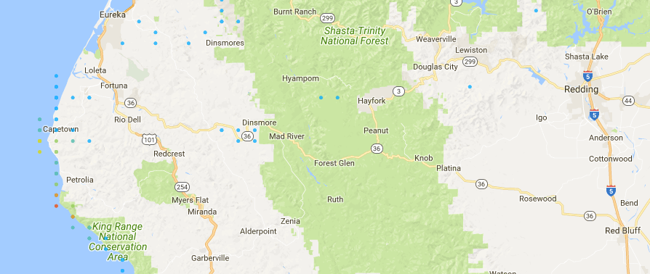

Wind data link: <https://maps.nrel.gov/wind-prospector>

For solar power, I select the similar area.

Redding, CA 🡪 (40.606730, - 122.379555)

Red Bluff, CA 🡪 (40.166566, -122.235196)

Thus, I count the sites (around 40, -inf~ - 122.235196) in CA

Actual (39.75, - 120)

<https://www.nrel.gov/grid/solar-integration-data.html>